Potential Sponsor:
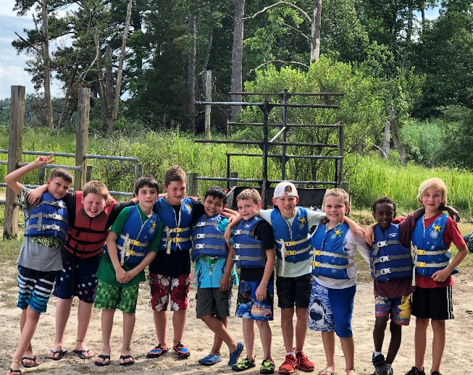
A few weeks ago, a boy named Whitt came to camp very apprehensively. His parents had communicated to us that he had speech and coordination development disorders, which had led to him being bullied at a previous camp. It didn’t take long until one of the children started to talk about his speech. The difference was when his counselor, Jordan, stood up for him and put a stop to it. He knew he had an advocate. This allowed him to feel more comfortable to recite the Bible memory verse and pray aloud. His parents even told us that they “found” him praying alone one evening, which he had never done. He was learning more about his faith, and growing in it, because of the relationships that had developed.
There are so many stories like this of children experiencing the love of Christ, through their counselors, which leads them to a deeper or new relationship with their Savior. We do not want any child to not be able to attend camp, and we want the experience to always be full of amazing adventure, just like following Christ is and will be. This is achieved by donors and fundraisers.
This year we are kicking off our first ever Camp Piankatank Winter 5K Run/Walk. We are making this a virtual race so that participants can complete it anytime during the month of December and submit their results online.
Please see the chart on the back of this letter for a description of the different sponsorship opportunities and the acknowledgements that you can receive. We need to receive all sponsor contributions by November 11th, in order to include your acknowledgement on the race shirts. You can send your contribution by mail, or make your donation online at www.camppiankatank.com/Sponsors.
With your help, we can continue to make a difference in the lives of children and teens in our community like Whitt. If you have any questions or concerns, please feel free to contact me.
In His Service,

Steve Gourley, Director

SPONSORSHIP OPPORTUNITIES
PLATINUM SPONSOR | GOLD SPONSOR | SILVER SPONSOR | RACE PARTNER SPONSOR
$750  (1 available) | $400  (4 available) | $200  (10 available) | $75  - available)
- 2”x 3.5” one-color logo on back of t-shirts in top center location*  - Large full-color logo on backdrop for photos and videos  - Full-color logo and link on web site for one year  - Special acknowledgement throughout race dates  - Acknowledged on social media weekly for 8 weeks  - Five free race entries  - First right of refusal for next year’s event | - 1.4”x2.5” one-color logo on back of t-shirts in a prominent location*  - Full-color logo on backdrop for photos and videos presentations  - Full-color logo and link on web site for one year  - Mention throughout race dates  - Acknowledged on social media weekly for 4 weeks  - Three free entries into the race  - First right of refusal for next year’s event | - 1.1” x 2” one-color logo on back of t-shirts*  - Full-color logo and link on web site for one year  - Mention on First Day of Race  - Acknowledged on social media  - One free entry into the race | - Company Name on back of t-shirts*  - Company Name on web site for one year  - Acknowledged on social media

*November 11th is the deadline for inclusion on the t-shirt.

Mail your contribution to:
Camp Piankatank PO Box 435 Hartfield VA 23071
Visit www.CampPiankatankWinter5k.com for more information

